PC Hardening – Firewall Analysis

The goal of this project is to understand how firewalls can be installed and used to harden a PC and protect it from outside threats. I also want to understand how network traffic interacts with the firewall by analysing the traffic, which will help me to identify any necessary applications and shrink my host’s attack surface.

1) Selecting the Firewall

Glasswire is a firewall that acts as a visual interface that is used to control the built-in Windows firewall engine. I decided to select Glasswire to harden my PC as it allows the user to monitor network traffic and gain insights on the best optimisations to protect data.

2) Installing the Firewall

I begin by installing Glasswire from their official website


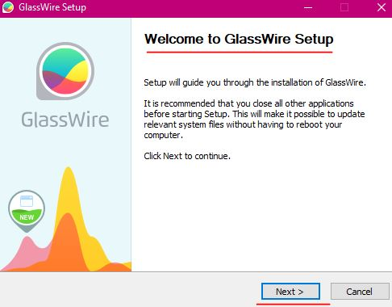
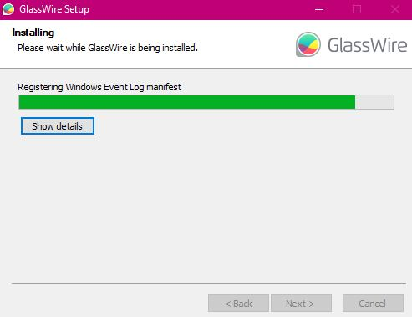

3) The Analysis and Information Gathering

After installing Glasswire, I decided to remain idle for 10-12 hours and allow Glasswire to collect and generate information about the traffic being blocked, as well as identify the sources for this traffic.
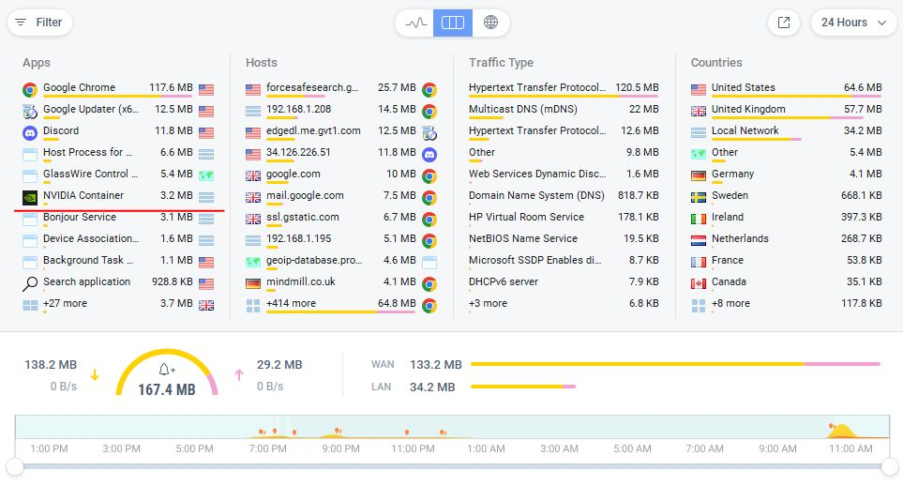
Upon analysing the results, I found that the NVIDIA Container’s first network connectivity occurred on the 14th of May at 18:50 and that this NVIDIA Container was being transmitted to my PC from America and Germany. I identified the NVIDIA Container to have a size of 3.8 MB which is automated background telemetry from update services. After deciding that this NVIDIA Container was an unnecessary entity within my PC and using the Principle of Least Privilege (PoLP) – which is a security concept in which certain users of systems have limited access rights or permissions to perform their goals/tasks) – I decided to block it.

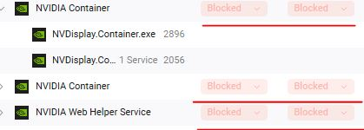

Overall, I am pleased with this outcome, as I have successfully engaged in Attack Surface Reduction and minimised the number of exploitable entry points that an attacker could use to enter my PC undetected.

